# The Witcher – The Last Quest Visual Workbook

This is a simple workbook to convey the tone of the series if it were ever produced. This specific book will focus on Velen, as that’s where the three episodes so far take place. I do apologize in advance for the nightmares, and for the fact that these are AI generated, I’m not amazing at photoshop or drawing so I decided that accuracy in tone > self-drawn.   
  
**Velen – The Continent’s War Ground**

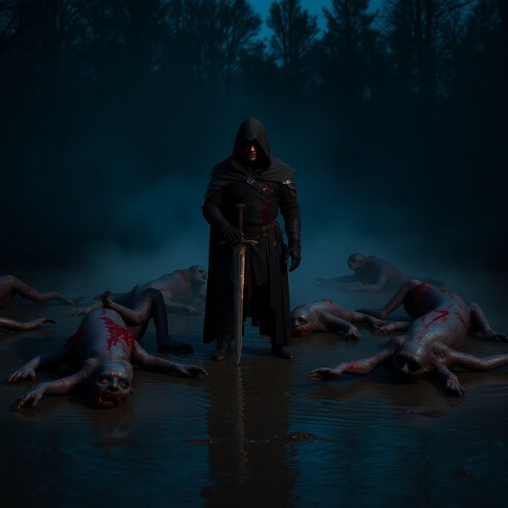**Dark, Mist Covered, Drowners like Zombies:  
  
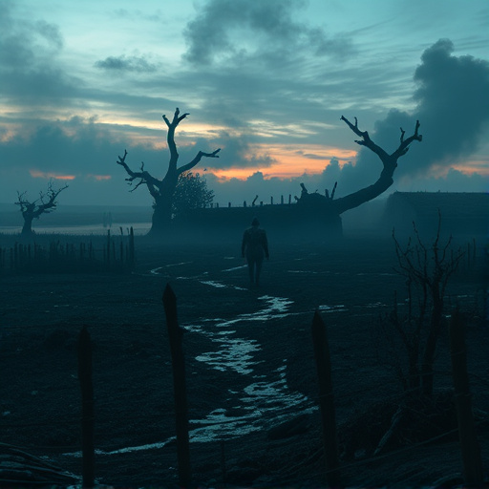**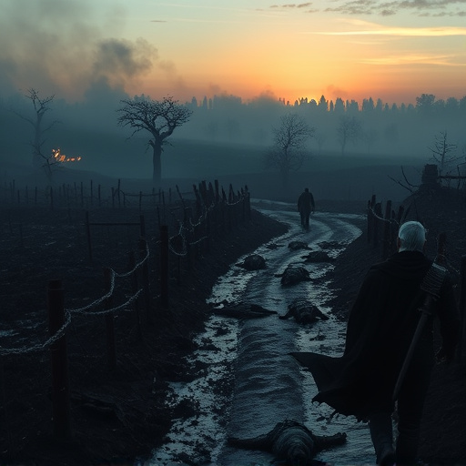

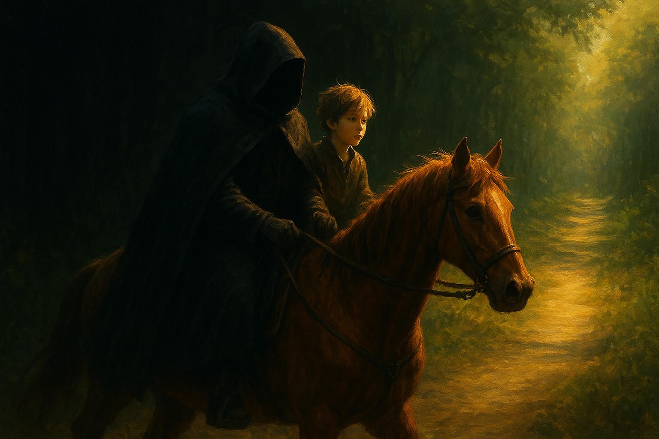**Geralt With Tobin, I like the use of the gold sun in this, emphasizing hope in the void, it works:**

**Keira Metz (darker than in game, but faithful to her design, focusing on the darker cinematic costuming):**

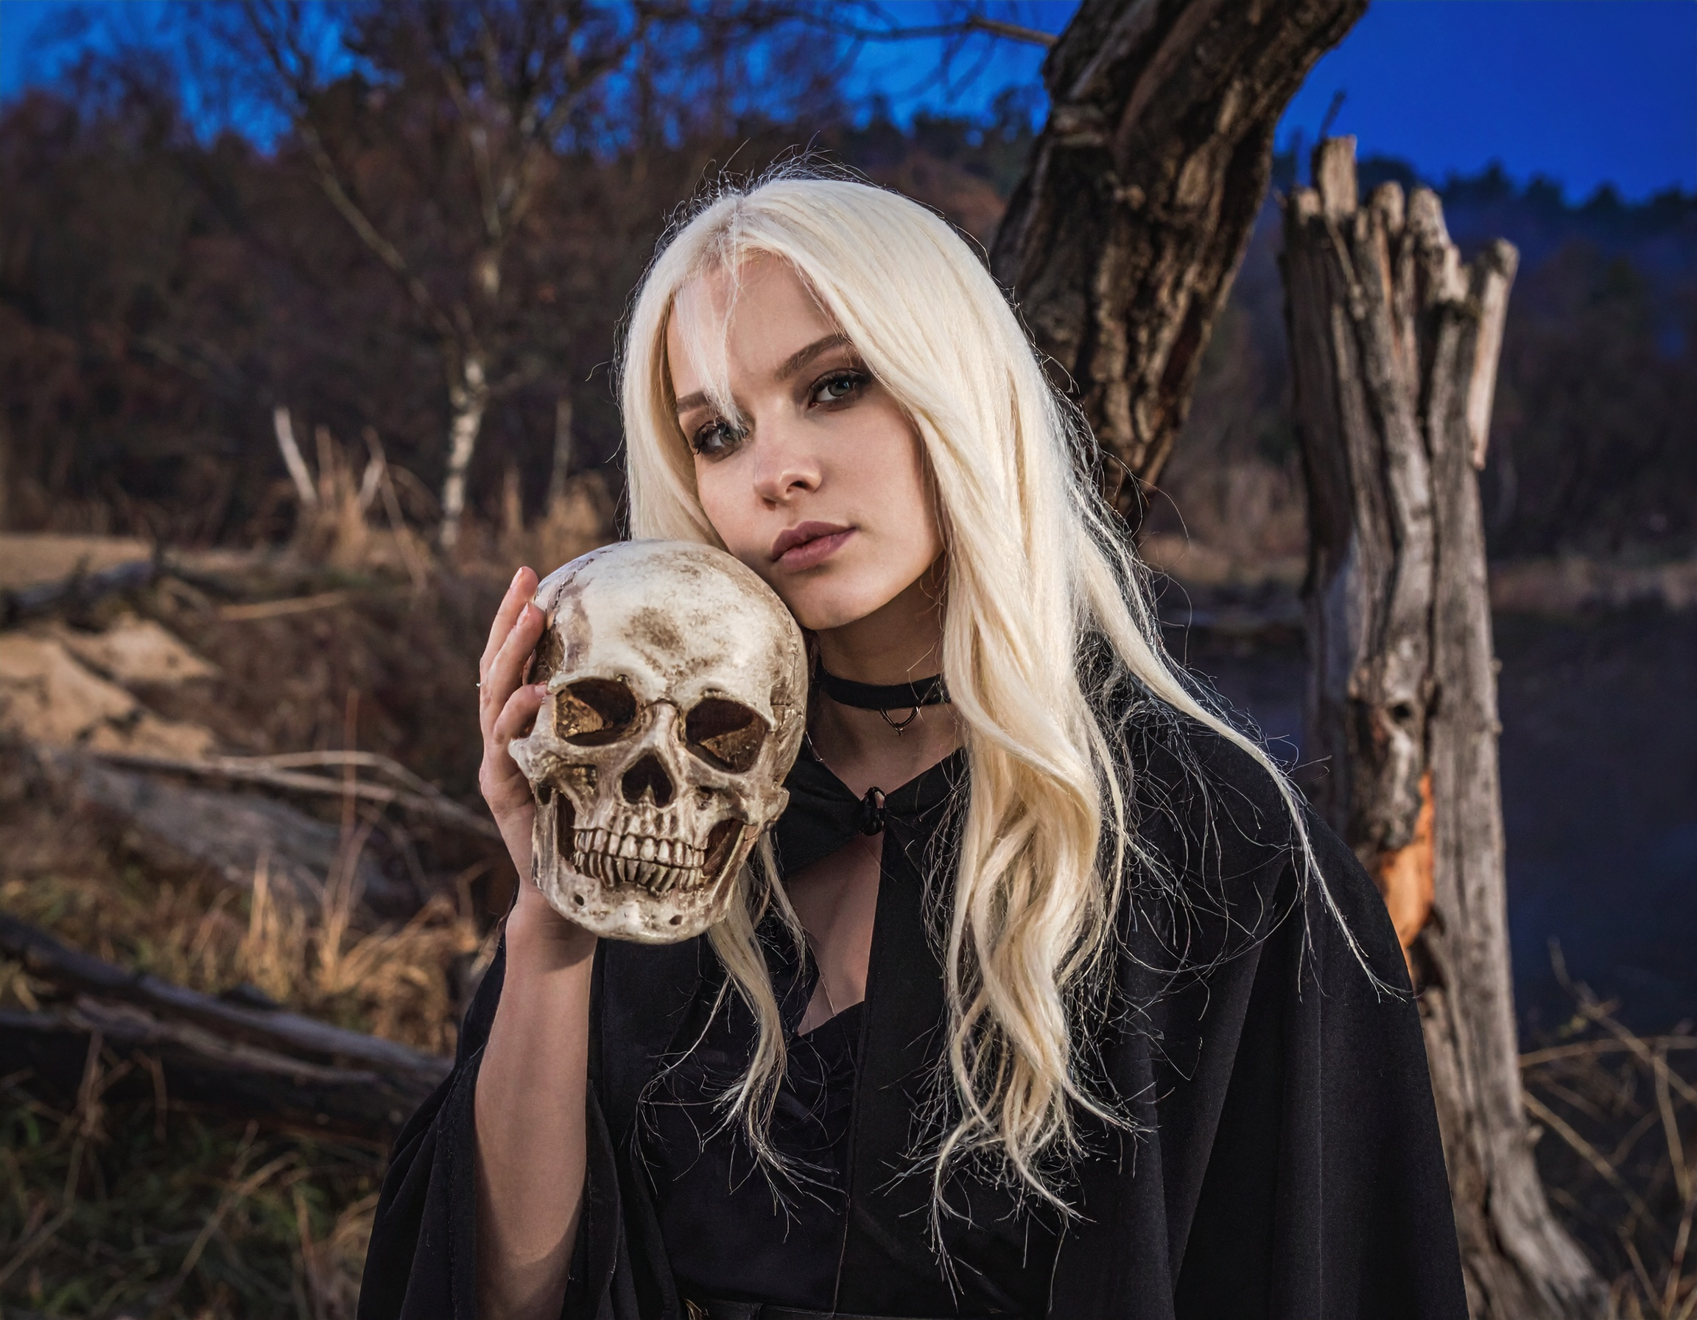**In game for reference on left, recreations on right and bottom:**

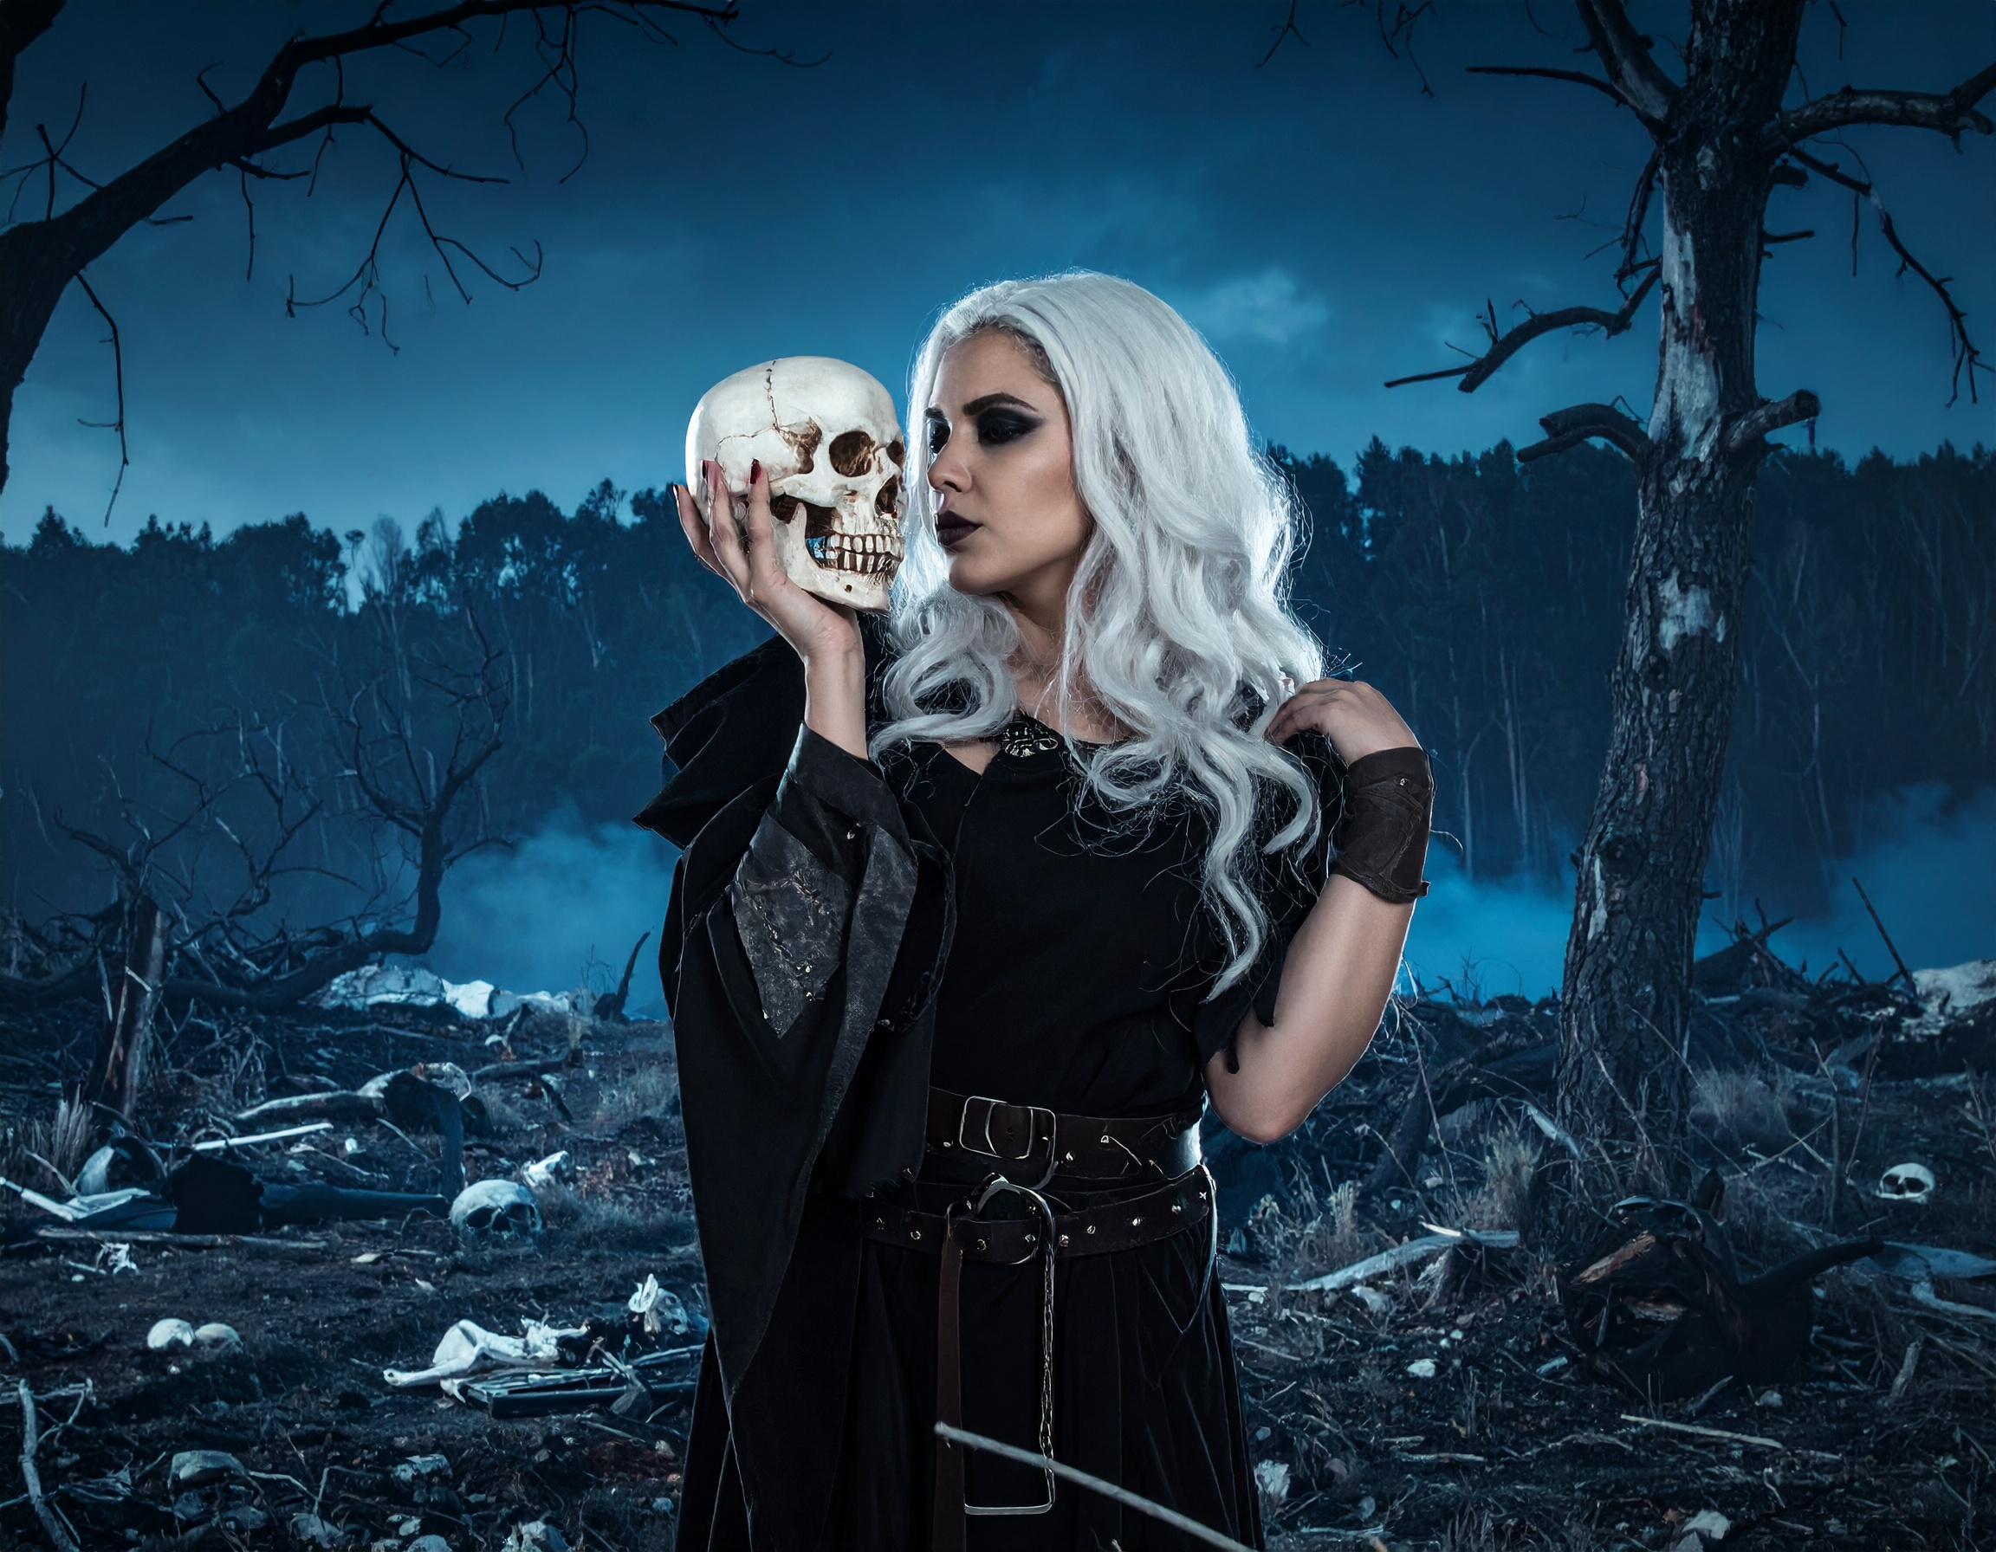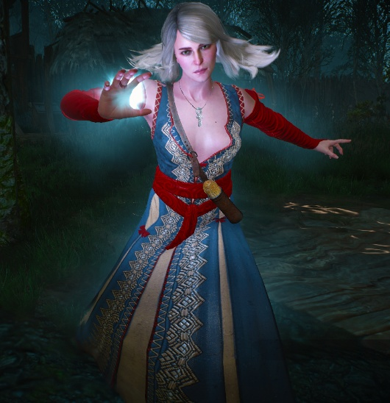

The Baron, just the game Baron, but on the left I do have an “Alternative look” for him, it’s more of a military leader look though:

